**Illustrative programs**

**4)** Python Program to Find Sum of Array

**Source code :**

1. “””
2. Python Program to Find Sum of Array
3. “””
4. #Display hint
5. print(“Enter a Value like this example\n”,”\tExample\n”, “\t1 2 3 4”)
6. #create a list
7. #split(), map()
8. list = list(map(int,input(“Enter a Value : “).split()))
9. #create a variable named sum
10. sum = 0
11. #create a for loop
12. for element in list:
13. sum = sum + element
14. #Display a result
15. print(“result :”,sum)

**Output :**

Enter a Value like this example

Example

1 2 3 4

**Enter a Value : 10 20 30**

Result : 60

**Proof :**

**Source code :**

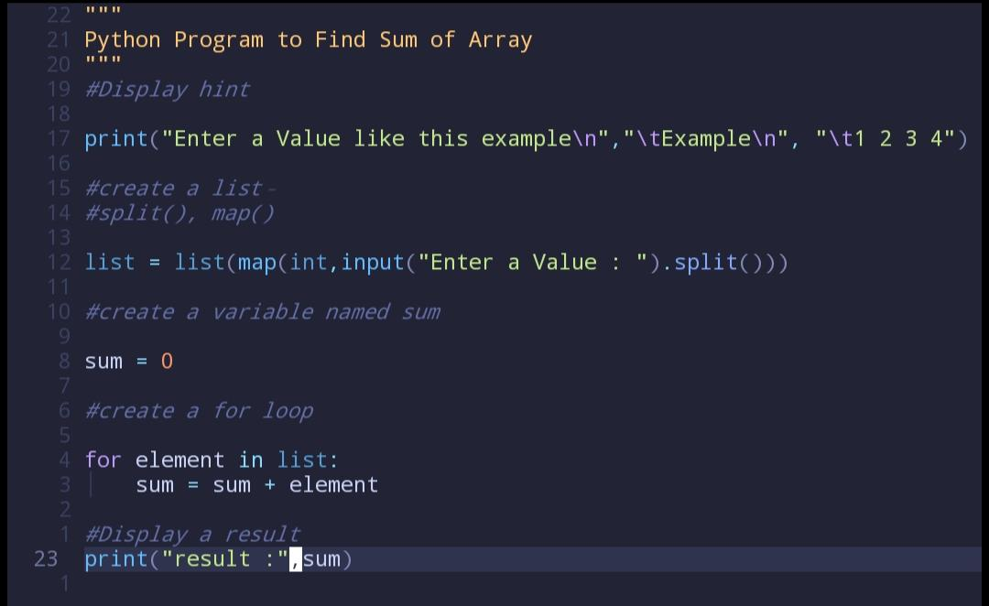

**Output :** 